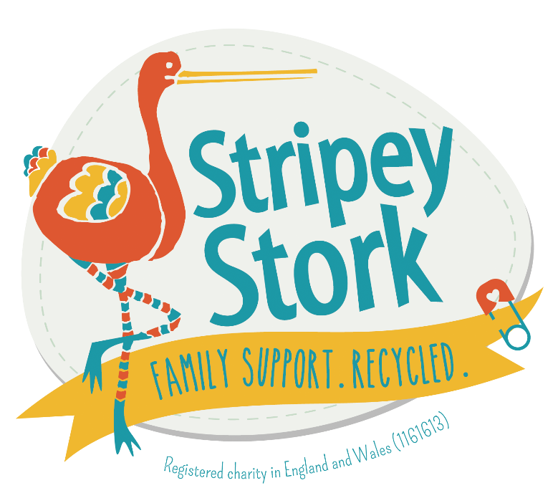

**Safeguarding Policy**

|  |  |
| --- | --- |
| Designated Safeguarding Lead | Sara Beadle, Operations Manager |
| Deputy Safeguarding Officer | Ruth Ritter, Volunteer Team Leader |

|  |  |
| --- | --- |
| Implementation date | *May 2024* |
| Review date | *9 July 2025* |

Signed on behalf of all trustees by:

|  |  |  |
| --- | --- | --- |
| Margarida Littlefair | Chair of Operations Committee | 9 July 2024 |
| Nicola Dawes | Chief Executive | 9 July 2024 |

1. **Preliminary**
   1. The Charity Commission has stated that safeguarding should be a key governance priority for all charities, regardless of size, type, or income, *not just those charities working with children or vulnerable adults*. It has also stated that it is essential for charity trustees to have and implement safeguarding policies and procedures and that they have to be adequate and appropriate for the charity’s particular circumstances.
   2. This Policy applies to all staff and volunteers of Stripey Stork (referred to in this policy as the “Charity”). In this Policy, “volunteers” means and includes the Charity’s trustees and all other volunteers.
2. **Commitment to safeguarding**
   1. Those who participate in the activities provided by the Charity or who come onto the Charity’s premises are referred to in this Policy as its “Service Users”. “Service Users” can include referral partners, visitors and young persons.
   2. Service Users may be at risk due to age, illness, or disability. The Charity is committed to working in their interests, to promote their welfare, and to put in place safeguards and measures to protect them. In providing activities for Service Users, the Charity will always endeavour to minimise risk to them and to ensure that they are as safe as the Charity can make them.
   3. The Charity aims to protect all its Service Users from any act or behaviour of any member of staff or volunteer which, whether deliberately or unknowingly on the part of that member of staff or volunteer, gives rise to harm or ill treatment.
   4. Such harm or ill treatment includes abuse (physical, sexual, emotional, discriminatory, institutional or organisational, financial or material), neglect, or impairment of the health or development of the Charity’s Service Users.
   5. The Charity also aims to ensure to promote the well-being and welfare of its Service Users*.*
   6. The Charity recognises that it has a duty to act on reports or suspicions of abuse or neglect. It adopts a “zero-tolerance” policy of abuse within the Charity.
   7. The Charity maintains a Safe Working Practice Guidance. It includes amongst other things:

(1) Harassment and Bullying Policy

(2) Lone Working Policy

(3) Mental Health and Stress Policy

(4) Domestic Abuse Policy

The Charity will ensure that the Guidance is implemented by all within the Charity and, for that purpose, it will ensure that its staff and volunteers have read and understood it.

* 1. The Charity will work in partnership with local / national agencies to put in place appropriate procedures for reporting, making referrals, and accessing training and specialist support, as and when required.

1. **Safe recruitment** 
   1. To aim to protect its Service Users, the Charity will seek to recruit staff, trustees and volunteers using appropriate procedures, safeguards and checks.
   2. The Charity will take up two references for all staff posts prior to appointment.
   3. The Charity will provide an induction programme for all new volunteers and staff, and appropriate training and ongoing/refresher training for them at regular intervals, to enable all volunteers and staff to undertake their roles safely, effectively, and confidently. The induction will make it clear to them that they have an obligation to implement this Policy and to learn about protection issues and their related responsibilities.
   4. Where the Charity should do so, it will use the Disclosure & Barring Service (“DBS”) checks to help it to assess suitability of a candidate for a particular volunteer or staff role which is treated by the DBS as Regulated Activity and is therefore subject to a barring list check. [Regulated activity refers to certain roles that involve working with children or vulnerable adults, from which the DBS has the power to bar people.] Inrelation to a post or role which is eligible for an enhanced DBS check, where the Charity considers it appropriate it will carry out an enhanced DBS check. The Charity will assess any criminal record information that is disclosed in line with its data protection and equalities (treating ex-offenders fairly) policies. Roles which would necessitate a standard DBS check include, but are not excluded to:
      1. Staff supporting volunteers (who may on occasions include children and vulnerable adults) or working, even temporarily, in a location with children or vulnerable adults (eg. school or nursing home). Staff supporting young volunteers regularly will be subject to enhanced DBS checks.
      2. Volunteer roles working, even temporarily, directly and alone with children or vulnerable adults, or in a location with children or vulnerable adults (eg. school or nursing home)
      3. Trustees.
   5. The Charity will regularly review its recruitment and other human resources procedures in response to changes in legislation and systems external to the Charity, e.g., DBS and barring list checks, and will take advice from a DBS processing agency about the appropriate level of check for a given situation.
2. **Volunteers** 
   1. All volunteer roles will be supported by a Volunteer Co-ordinator.
   2. Volunteers will be treated equally alongside paid staff, and all volunteers will be offered the same opportunities for advancement, responsibility, training and gaining qualifications, and acknowledgement for their contribution to the Charity.
   3. Before they take up their role, they will each be given a clear description of the requirements and responsibilities of their role and the member of staff or trustee recruiting them will discuss their role with them, to ensure that they understand what is expected of them.
   4. Any volunteer roles, which would be Regulated Activity if unsupervised, will be appropriately supervised in accordance with statutory guidance. Such roles will not be undertaken without the presence of DBS-checked paid staff.
3. **Safeguarding Officer** 
   1. The Charity’s appointed Designated Safeguarding Lead, as from 25th March 2022 is Sara Beadle, Operations Manager, and they are supported by Ruth Ritter, Volunteer Team Leader as Deputy Safeguarding Officer. They will have access to appropriate training to support them in these roles.
   2. They will be available to all staff, volunteers and Service Users to speak to when they have any concerns, issues, or complaints regarding the safety, well-being or conduct of Service Users, volunteers or staff.
   3. The Designated Safeguarding Lead and Deputy Safeguarding Officer will liaise with appropriate local and national agencies, contribute to appropriate policies, maintain records, keep confidentiality, adhere to and promote this Policy within the Charity, and support or provide access to support for individuals suffering harm or abuse.
4. **Awareness of harm and abuse within the Charity**
   1. All incidents of harm to any Service User will require an appropriate response to reduce risks and improve the Charity’s activities.
   2. Harm is caused by accidents, deliberate abuse (physical, psychological, sexual, emotional, financial), neglect (deliberate or not) or factors such as bullying, prejudicial attitudes, or a failure to enable a person to participate in activities that are open to most of their peers. It can also include abuse via use of ICT facilities (e.g. grooming, bullying via the internet).
   3. Deliberate acts of harm (physical, psychological, sexual, emotional and financial) and neglect are abuses against the person. Those acts will incur disciplinary proceedings and require reports and referrals to social services, the police, other professional bodies, and the DBS if the act is by someone in Regulated Activity. If a criminal offence is thought to have been committed by any staff member or volunteer, the police will be informed.
5. **Confidentiality**

All reports and logs (including personnel records) will be kept securely and confidentially according to the Charity’s Data Protection Policy, unless it is necessary to share this material with the agencies named above. Information will be shared by the Charity on a “need-to-know” basis only.

1. **Reports of possible or actual harm**
   1. The Charity supports and encourages all Service Users, volunteers and staff to promptly speak up and contact the Safeguarding Officer or Deputy Safeguarding Officer where there is a concern (i.e. a worry, issue or doubt about practice or about treatment of a Service User or colleague, or their circumstances), or a disclosure (i.e. information about a person at risk of or suffering from Significant Harm) or an allegation of an incident or a possibility that a volunteer or staff member has caused harm or could cause harm to a person in their care.
   2. Staff or volunteers can report, and have a responsibility to report, something that they become aware of if they suspect or discover that it is not right or is illegal or if it appears to them that someone at work is neglecting their duties, putting someone’s health and safety in danger or covering up wrongdoing. They may become aware of any of these things from what they see or hear or from something another person has disclosed to them.
   3. In the first instance the staff or volunteer making a report should speak to their line manager who will then liaise with the Designated Safeguarding Lead, Deputy Safeguarding Officer or the Charity’s trustee with appropriate responsibility who is Lynn Turner, HR Trustee. However, if the report implicates their line manager, the staff member or volunteer making the report should instead speak directly to Safeguarding Officer, Deputy Safeguarding Officer or that trustee.
   4. The Charity prefers that anyone should use internal processes whenever possible to make a report as above, but this does not prevent them from making a report or referral, in their own right as a private individual, to statutory agencies such as social services or the police.
   5. More detailed guidance in accordance with the NSPCC and current statutory guidance for responding to the disclosure of an reporting possible child abuse is available in the document ‘Stripey Stork Safeguarding Procedures Guidance’. The Designated Safeguarding Lead can provide a copy of this if you do not have one.
   6. The Charity cannot promise confidentiality to staff or volunteers making an internal report (to the Safeguarding Officer, Deputy Safeguarding Officer, the Charity’s trustee with appropriate responsibility or their line manager) where it has to be shared with any statutory agencies.
   7. The Charity also supports its staff or volunteers to raise concerns or to disclose information, which they believe shows malpractice - whistle-blowing (disclosure in the public interest).
2. **Online Abuse**

9.1 The Charity will take a greater interest in training and awareness around online abuse and recognising the signs of that in the people we work with. See guidance procedure document.

1. **Designated Safeguarding Lead’s action**

Where there is risk of Significant Harm to any Service User, volunteers or staff, the Designated Safeguarding Lead and Deputy Safeguarding Officer have the power to act as necessary and, in particular, as follows:

- log all conversations regarding the issue

- sign and request signatures on reports and statements

- confidentially seek advice from expert sources

- share concerns (with consent where required and appropriate) internally with senior staff / Chair of the Board of trustees

- share concerns and make referrals to external agencies such as social services or the police, as appropriate to the circumstances

- make a referral to the DBS regarding staff or volunteers in Regulated Activity whose conduct is harmful to Service Users and refer them to DBS when they are removed from Regulated Activity.

1. **Communication by the Charity about safeguarding and this Policy** 
   1. All staff and volunteers have an obligation to learn about protection issues and their related responsibilities.
   2. The Charity will communicate this Policy (using appropriate methods, formats and language to communicate the substance of it) to all of its staff, volunteers, and Service Users, and it will also make it available to the public. Nicola Dawes, Chief Executive, will be responsible to the Board of trustees for communicating this Policy to them.
   3. To encourage everyone involved in the Charity to understand that safeguarding is the business of everyone, and to assist all staff and volunteers to learn about protection issues and their related responsibilities.
2. **Implementation of this Policy**
   1. This Policy must be followed by all staff and volunteers of the Charity and must be promoted by all of its trustees and senior staff. Failure to follow it will be treated as a very serious matter.
   2. This Policy needs to be read in conjunction with the following policies and procedures of the Charity:

Health & Safety Policy

Data Protection Policy

Equal Opportunities and Diversity Policy

Safeguarding Procedures Guidance Document

1. **Adoption, coming into effect, and review, of this Policy**
   1. This Safeguarding Policy was approved by the Operations Sub-Committee on behalf of the Board of trustees of Stripey Stork on 9 July 2024
   2. The Board will, as appropriate, monitor and enforce this Policy,
   3. The Board will review this Policy on an annual basis. The next date for review of this Policy by the Board will May 2025.